📝 Discussion Board – Must Post First
Require students to post before seeing classmates’ responses

Why Use “Must Post First”?
- Prevents students from passively reading others’ responses before forming their own.
- Encourages original thought and more diverse discussions.
- Helps reduce repetitive responses where students mimic previous posts.

📌 How to Enable “Must Post First” in D2L Brightspace

- Navigate to Discussions
  - Go to your Course Homepage.
  - Click on Discussions from the Navbar under Activities.
- Create or Edit a Discussion Topic
  - Click New Discussion Topic or select an existing topic to edit.
- Enable "Must Post First"
  - On the right side, expand Post & Completion
  - Check the box “Learners must start a thread before they can read and reply to other threads”.
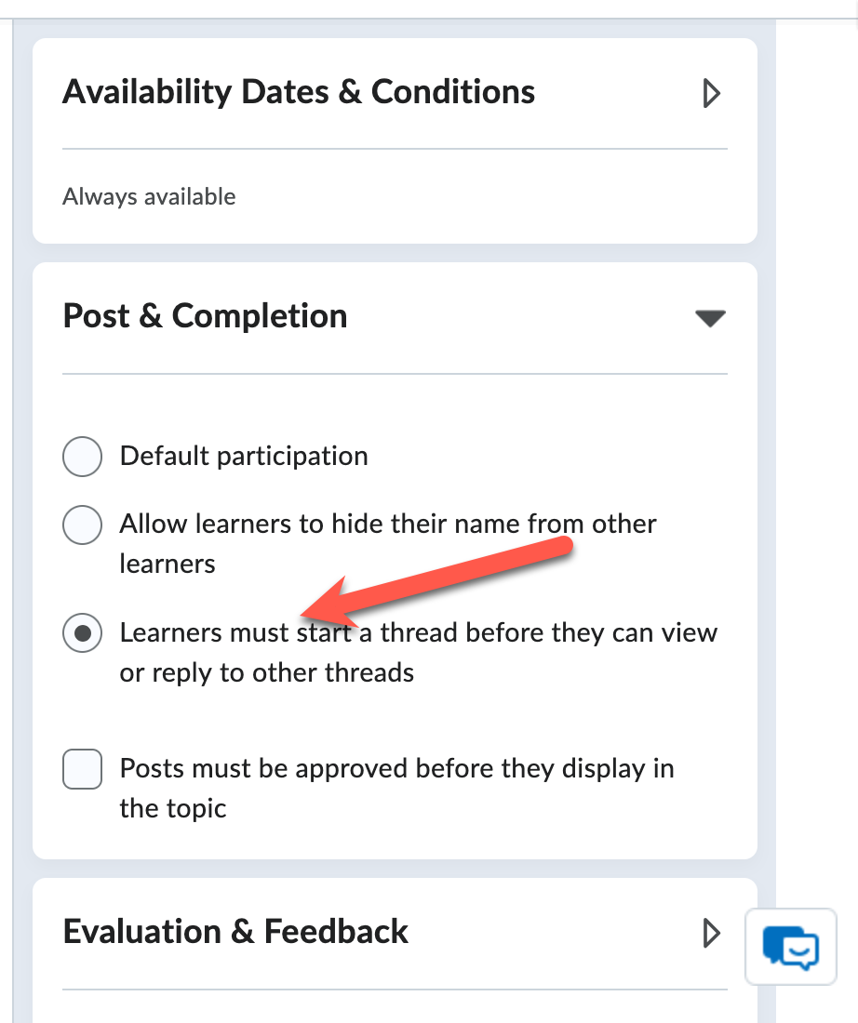
- Save and Close
  - Click Save and Close to apply the setting.

💡 Additional Tips & Best Practices
✅ Set Clear Expectations – Let students know they won’t see other posts until they contribute.
✅ Encourage Critical Thinking – Provide open-ended prompts that require analysis or personal reflection.
✅ Use Rubrics for Grading – Attach a rubric to evaluate participation quality.

